**Defuse the Bomb – Proportion**

The Mathematician, a notorious terrorist has planted a bomb. You must defuse that bomb using the mathematical clues he’s left.

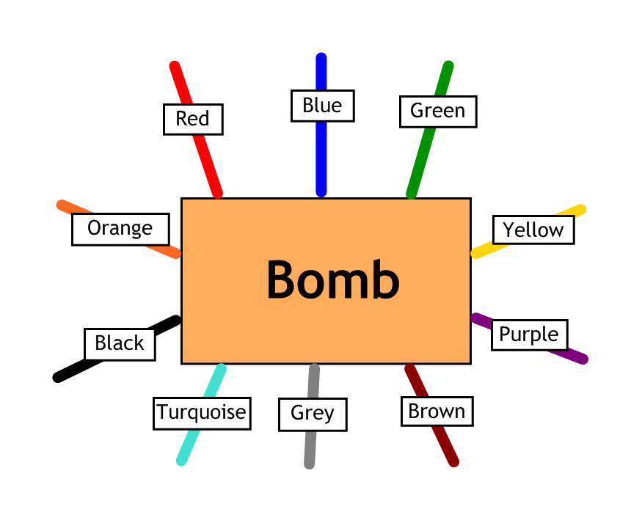

Answer the questions, then cut the coloured wires in the order that the answers appear, using the table below:

|  |  |  |  |  |  |  |  |  |  |
| --- | --- | --- | --- | --- | --- | --- | --- | --- | --- |
| Red | Blue | Green | Yellow | Purple | Brown | Grey | Turquoise | Black | Orange |
| 4 | 75 | 8 | 14 | 28 | 24 | 18 | 16 | 20 | 56 |

Here are the clues that show which order to cut the wires:

|  |  |
| --- | --- |
| 1 | $a$ is directly proportional to $b$.  When $a$ is 3, $b$ is 12.  What is $b$ when $a=7$? |
| 2 | $c$ is inversely proportional to $d$.  When $c$ is 3, $d$ is 12.  What is $c$ when $d=9$? |
| 3 | $e$ is directly proportional to $f^{2}$.  When $e$ is 12, $f$ is 2.  What is $f$ when $e=5$? |
| 4 | $g$ is directly proportional to $h$.  When $g$ is 4, $h$ is 10.  What is $g$ when $h=35$? |
| 5 | $j$ is inversely proportional to $k$.  When $j$ is 6, $k$ is 8.  What is $k$ when $j=3$? |
| 6 | $m$ is inversely proportional to $n^{2}$.  When $m$ is 2, $n$ is 6.  What is $m$ when $n=2$? |
| 7 | $p$ is directly proportional to $\sqrt{q}$.  When $p$ is 12, $q$ is 9.  What is $p$ when $q=25$? |
| 8 | $x$ is inversely proportional to $y^{3}$.  When $x$ is 27, $y$ is 2.  What is $x$ when $y=3$? |